Part 1
Evaluate the following Boolean expressions in IDLE:
7 and 5
True and True
True and False or True
False or False and True
False or 0
not (False) and True
not (True or not (False and False))
(10 > 14) and (4 == 5)
True and 5
(3 * 4)! = (14 - 2) or (‘C’ >= ’D’)
(12 * 2) == (3 * 8)
(14 * 2)! = (3 * 8)
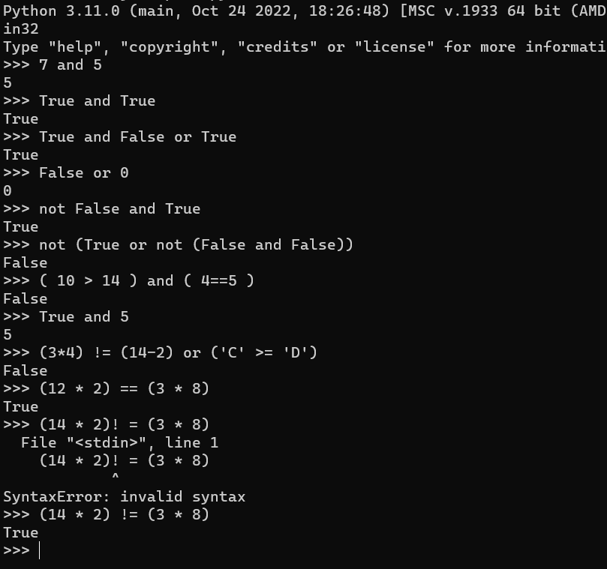
Part 2
1. Evaluate the following expressions for num1 = 10 and num2 = 20.
(a) not (num1 < 1) and num2 < 10
(b) not (num1 < 1) and num2 < 10 or num1 + num3 < 100 (c) not (num2 > 1) or num1 > num2 - 10
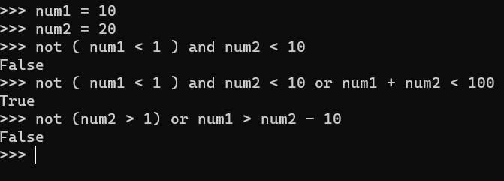
2. Write a python program to find the sum and product of two numbers.
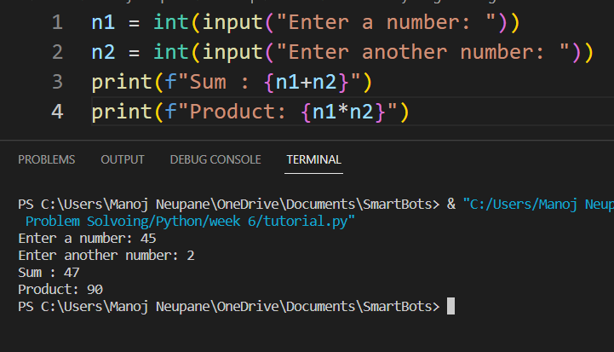

3. Write a python program to input first name, last name, and address. Print them.
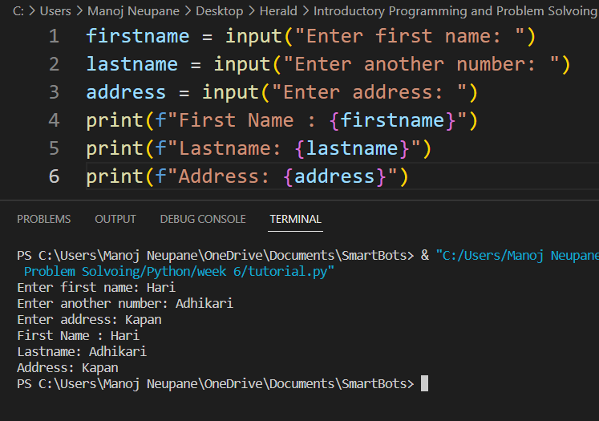

4. Write a python program to input three numbers and find their sum.
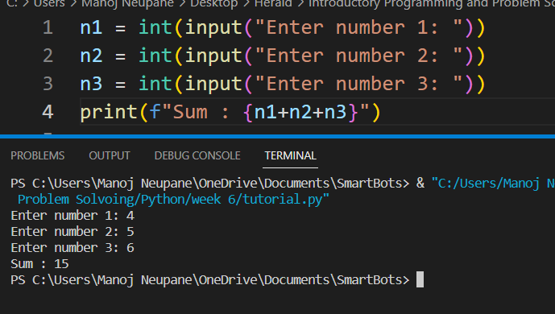
5. Write a python program to print the area of circle. Take radius of circle as an input form the user.
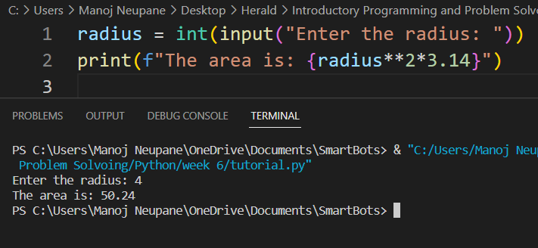

Part 3
1. Write a program that:
(a) Asks to input the user’s weight in kilograms
(b) Asks to input the user’s height in centimeters.
(c) Calculates the BMI (Body Mass Index).
[BMI=weight in kilograms / square of height in meters]
(d) Prints the user’s BMI.
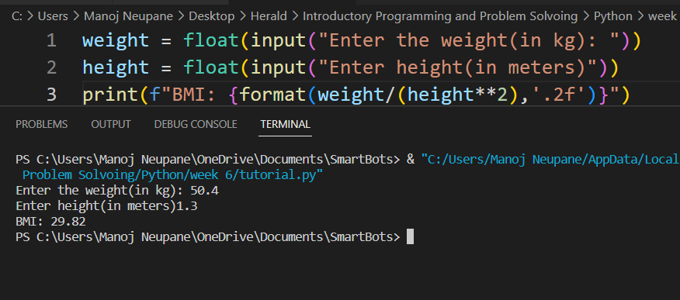
2. An observer sees the shadow of a bird at mid-day.
(a) The distance between the observer and the shadow is 15 meters.
(b) The perpendicular distance between the bird and its shadow is 25 meters.
(c) Find the total distance between the bird and the observer.
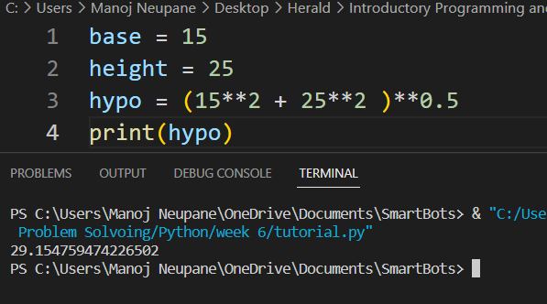

3. A costumer walks in a flower shop and finds the following menu:
Particulars | White Roses | Lilies | Poppies | Marigold | Red Roses
Per piece | 50 | 50 | 40 | 20 | 100
Per bouquet | 300 | 300 | 250 | 200 | 1000
If the user bought a bouquet of lilies and four red roses, find the total money the user spent in the flower shop.
4. Take user’s name, age and address as input and generate a formatted output using python scripting. [Use %d and %s to generate the output]
5. Calculate the VAT amount of a gadget the user bought using the built-in python format function within two decimal digits. Input the cost price from the user. [VAT =13%]
Part 4 (Home Task)
1. Give an appropriate if statement for each of the following
(The value of num is not important):
(a) Displays 'within range' if num is between 0 and 100, inclusive.
(b) Displays 'within range' if num is between 0 and 100, inclusive, and displays 'out of range' otherwise.
2. Rewrite the following if-else statements using a single if statement and elif:
if temperature >= 85 and humidity > 60:
print ('muggy day today')
else:
if temperature >= 85:
print ('warm, but not muggy today')
else:
if temperature >= 65:
print ('pleasant today')
else:
if temperature <= 45:
print ('cold today')
else:
print ('cool today')
3. Write a Python program in which:
(a) The user enters either 'A', 'B', or 'C'. If 'A' is entered, the program should display the word 'Apple'; if 'B' is entered, it displays 'Banana'; and if 'C' is entered, it displays 'Coconut'. Use nested if statements for this.
(b) Repeat question (a) using an if statement with elif headers instead.
(c) A student enters the number of college credits earned. If the number of credits is greater than or equal to 90, 'Senior Status' is displayed; if greater than or equal to 60, 'Junior Status' is displayed; if greater than or equal to 30, 'Sophomore Status' is displayed; else, 'Freshman Status' is displayed.
(e) The user enters a number. If the number is divisible by 3, the word ‘Fizz’ should be displayed; if the number is divisible by 5 the word ‘Buzz’ should be displayed and if the number is divisible by both ‘FizzBuzz’ should be displayed.
5. Create a program using the schematic below to help you decide whether it is okay to eat something that you dropped on the floor…
Note: this is not genuine advice on health and hygiene ;)
